|  |
| --- |
| Solid Edge Tutorial  **Introduction to wiring your FIRST® Robot** |
|  |
| **Siemens Digital Industries Software** |

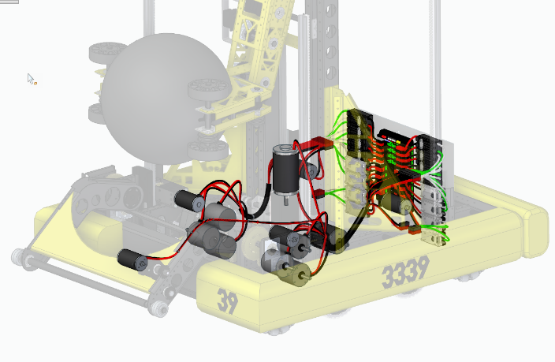**Electrical Wire Routing**

In this tutorial you will learn how to use Solid Edge’s electric routing to   
add wire paths and physical wires to a FIRST® robot. To demonstrate this   
process, we will be using an award winning FIRST® robot, courtesy of   
[Team 3339 -BumbleB](https://www.thebluealliance.com/team/3339) from Israel.

**Video #1**

* From the Browse dialog, navigate to the 2019-BumlbeB folder   
  inside the Class File folder.
  + Change the filter to Top Level Assembly documents (.asm).
  + 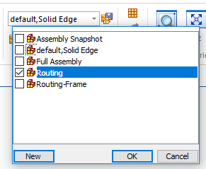Select **Robot Assembly-With Wires.asm**.
  + Change the “Assembly open as” setting to **Last Saved**.
    - This activates only the parts we need in the assembly.
* On the Home tab, change the configuration to Routing from the drop list.
  + This temporarily hides parts of the assembly and helps us focus   
    on the components we need to add wires too.
  + Notice that the wires are already routed on the right side of the   
    robot. We will now focus on the left sid
* 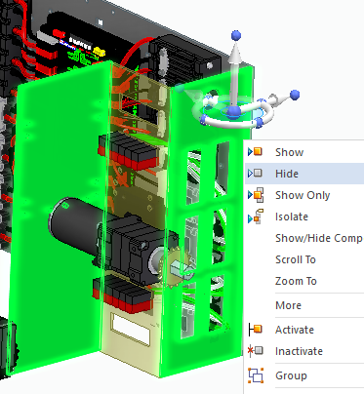Hide the two plates shown by selecting the and picking   
  Hide from the right mouse click menu.
* 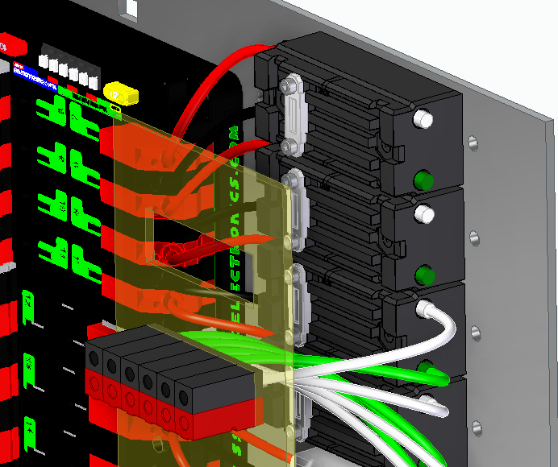Zoom up on the electrical connectors and control unit  
  as shown.

* 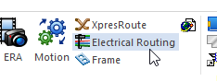From the Tools tab, select Electrical Routing.
* Select the Path command.
  + 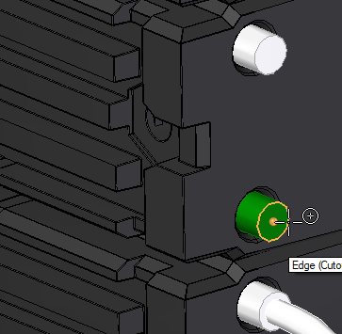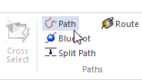Be sure the Locate filter is set to Center Point
  + Select the center point of the lower Green terminal   
    on the Motor Controller second from the top as shown.
  + Terminate the path on the Green terminal in the   
    Connector as shown
    - Be sure to get the circle center point at the   
      bottom of the hole in the Connector part.  
      This will ensure the path is created in the  
      proper direction.
  + Click the green checkmark to accept and then click Finish to complete the Path.

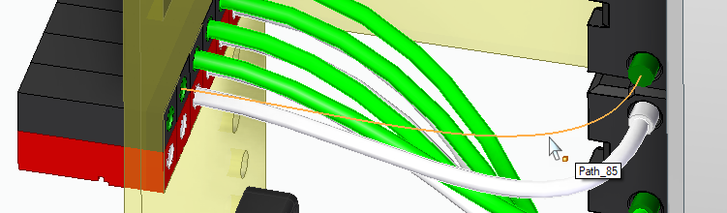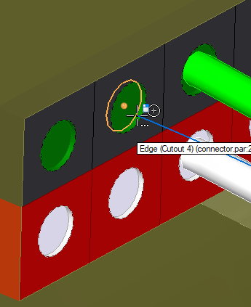

* + 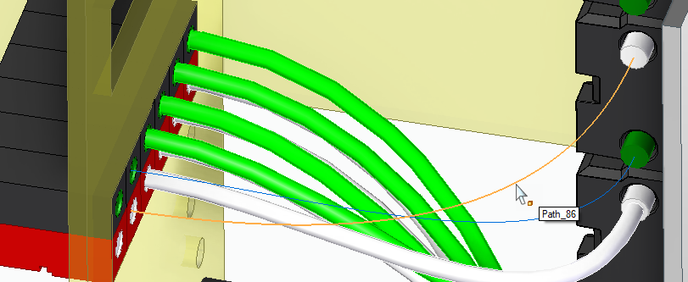While still in the Path command, select the   
    white terminal on the Motor Controller,   
    directly above the previously selected terminal,  
    and route to the white terminal in the   
    connector like before.
  + 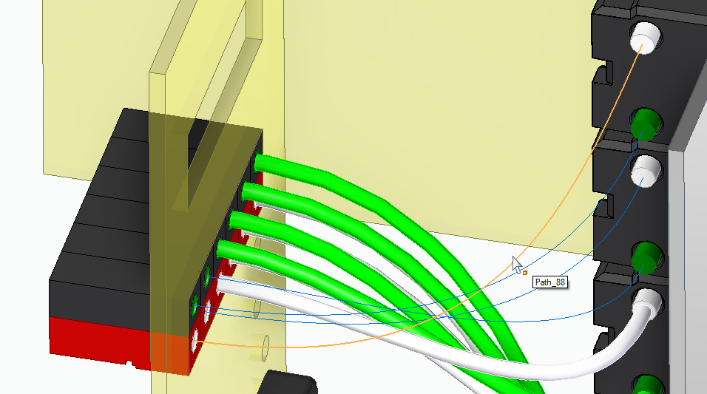Repeat the procedure for the top most   
    Motor Controller to route to the terminal   
    in the outermost connector.
* 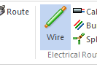Next we will assign physical wire definitions to the   
  paths we just created using the Wire command.
  + Be sure the option in the quickbar is set to select   
    “Use Existing Path”.
  + Select the top path connecting the white terminals and accept with the green checkmark or RMB click.
  + Change the wire properties from the drop list to **12-gage Stranded Copper White** and click Preview and then Finish.
    - 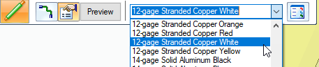Type in a descriptive name (Wire-MC-9 Neg) for the wire before clicking finish.
  + Select the other path connecting the white terminals, and because the previous settings are remembered, you may RMB click 2 times to assign the same wire properties to the second wire.
    - Type in (Wire-MC-10 Neg) for the wire before clicking finish.
  + 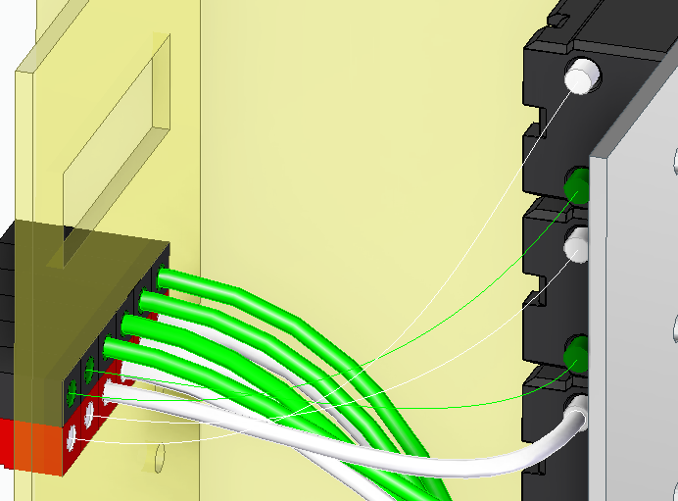Repeat this process for the paths connecting the green   
    terminals but change the wire properties to   
    **12-gage Stranded Copper Green** and name them:
    - Top wire as Wire-MC-9 Pos
    - Bottom wire as Wire-MC-10 Pos
* With the Select tool active, select the 4 wires we just created by pressing and holding the CTRL key and picking the 4 wires.
  + 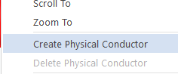Once selected RMB click in space and select “Create Physical Conductor”   
    from the pop-up menu.
  + 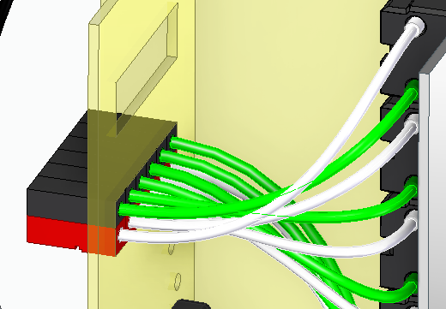This adds the physical model   
    of the wires to the paths.

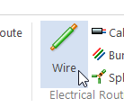**Video #2**

* The wire path can also be created as part of the Wire command.
  + 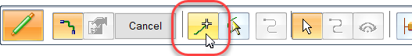Run the Wire command and set the option to Create Path.
  + 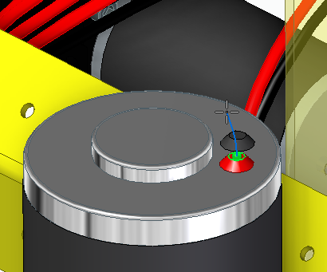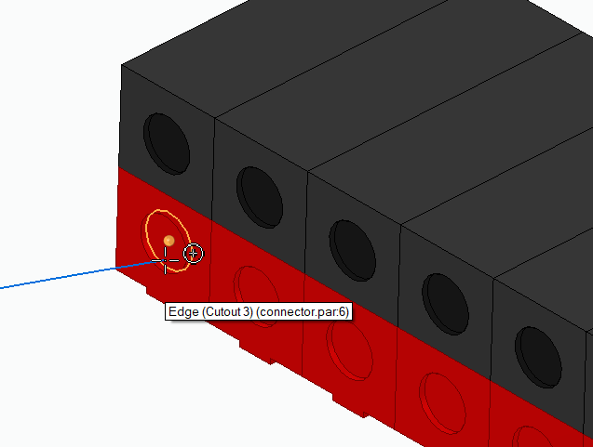Select the top circular edge of red terminal on the Arm Motor (BumbleB0227.par) for the start of the path and the **inside** red circular face on the Connector on the left side of the connector stack.
  + Accept the path with the green checkmark.
  + Set the wire properties to **12-gage Stranded Copper Red** and click Preview.
* 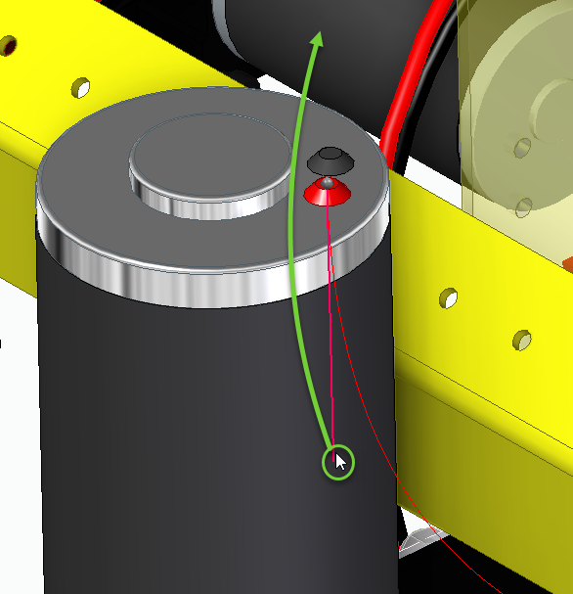Note that the wire inverted coming out of the motor as it was   
  the shortest path to the terminal.
  + 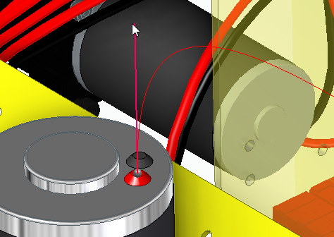We can fix that by left click and dragging the end of the   
    tangency handle above the motor to reset the direction   
    of the wire coming from the terminal.
  + Rename the Wire from the default name to **Arm Motor Pos** and click **Finish**.
  + Repeat this process to create the black wire connected to the black terminals.
    - Change the wire properties to **12-gage Stranded Copper Black.**
    - Adjust the tangency.
    - 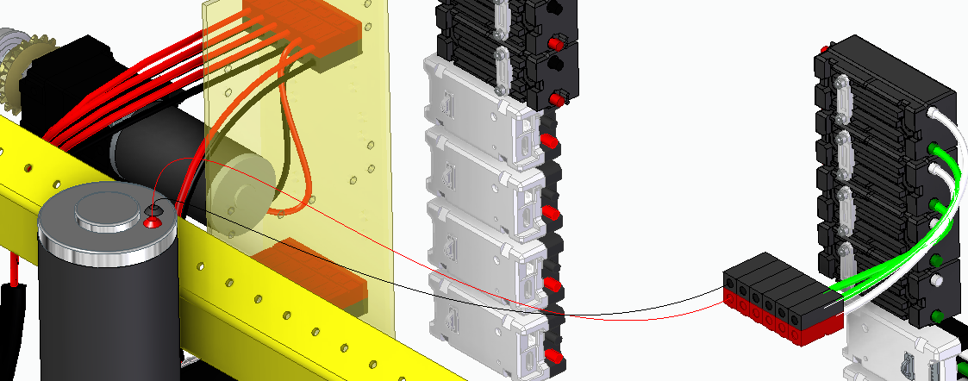Change the name to **Arm Motor Neg** and click **Finish**.
* 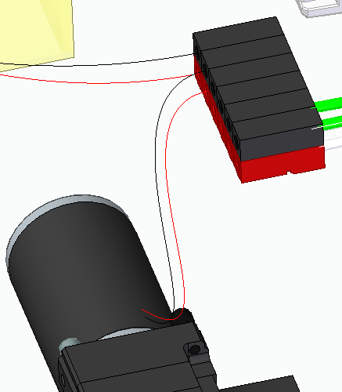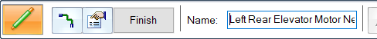Continue with the same workflow to add red (Pos) and black (Neg) wires   
  connecting the **Left Rear Elevator Motor** to the next **Connector** in the row.
* Add red (Pos) and black (Neg) wires connecting the **Left Front Elevator Motor**to the next **Connector** in the row.
  + 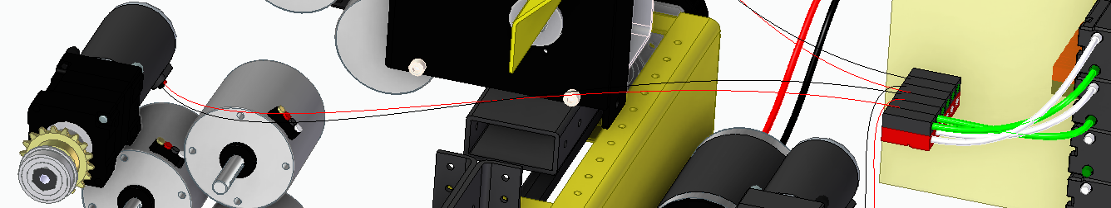Adjust the tangency as necessary.

* Add red (Pos) and black (Neg) wires connecting the 3 left Drive Motors to the remaining Connectors.
  + **Left Upper Drive Motor (Pos and Neg)**
  + **Left Middle Drive Motor (Pos and Neg)**
  + 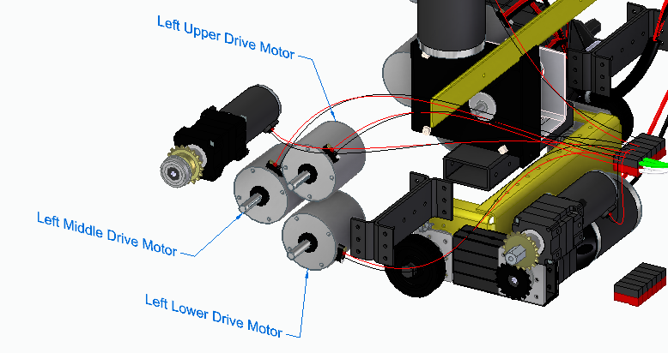**Left Lower Drive Motor (Pos and Neg)**

**Video #3**

* 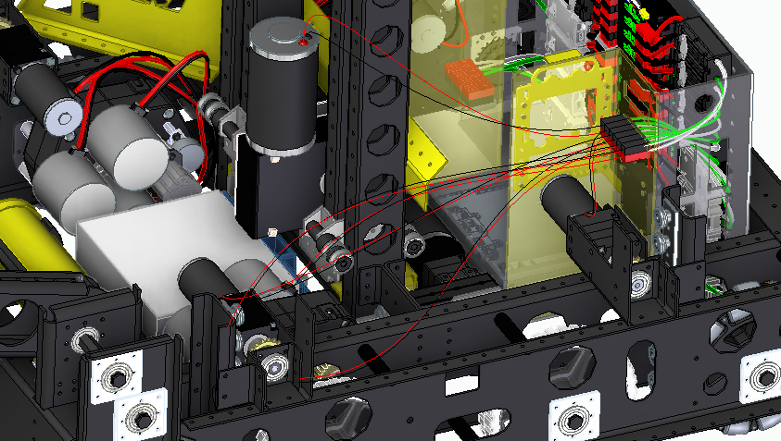Next, we will need to bundle the wires   
  together and route them down through   
  an opening in the frame so as not to   
  interfere with other assembly components.
  + 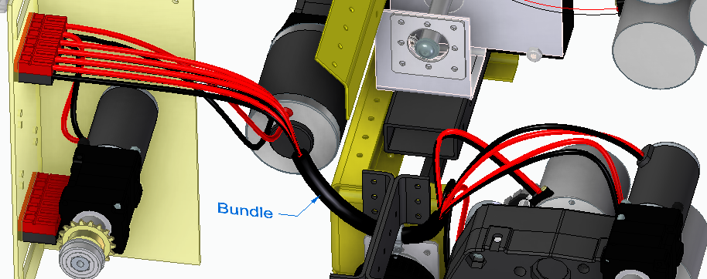We will create a bundle similar  
    to the right side.
* Transition to a Front view using the View Cube or CTL+F.
* 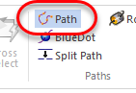Run the Path command.
  + Start the Path at approximately the left end of the Bundle  
    on the far side.
  + For the second point, pick up the center point of the   
    circular edge of the Zip tie.
  + 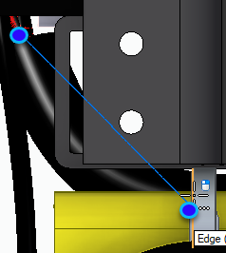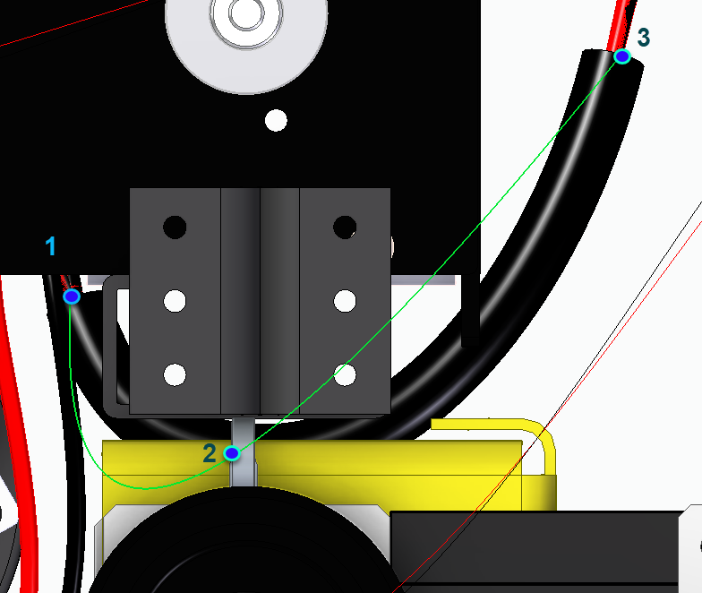Click near the right endpoint of the Bundle on the   
    opposie side for the 3rd point.
  + Select the green checkmark to accept the Path, but DO NOT click Finish.
  + Go to the Select Points Step in the command bar.
    - 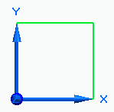Rotate the view and Lock to the X,Y plane of the  
      triad by highlighting the plane and left clicking.
    - Press CTL+T to transition to a top view.
    - Click and drag the left endpoint of the Path to   
      where the motor wires are located.
    - Adjust the right end if necessary.
    - 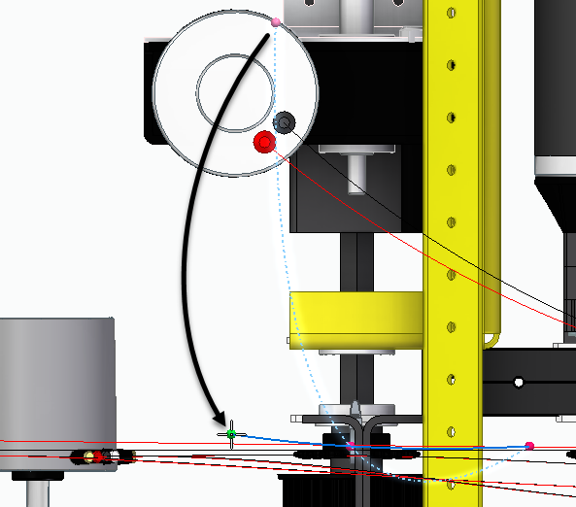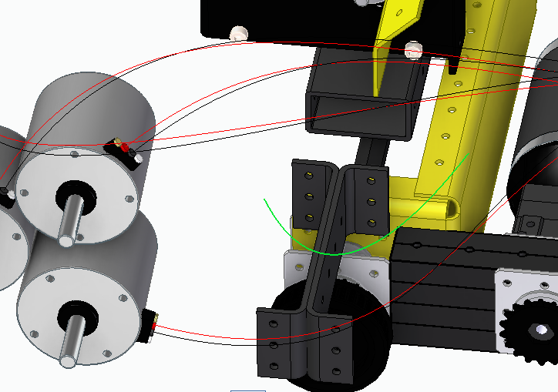Click the green checkmark to accept the changes.
* 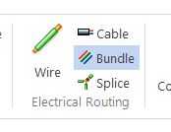Run the Bundle command.
  + 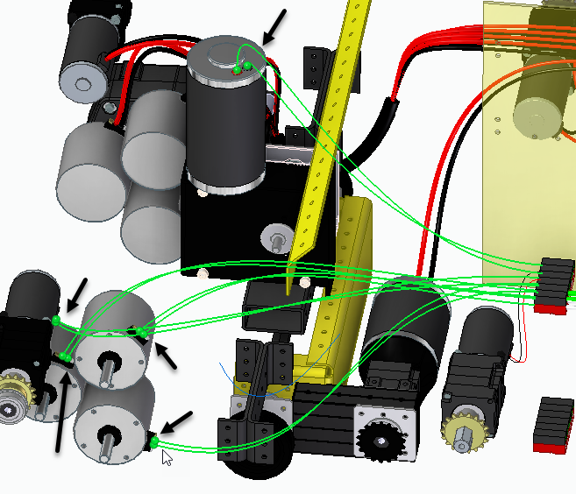Select the red and black wires near   
    the motor-end of the wires (10 wires):
    - Arm Motor
    - Left Front Elevator Motor
    - Upper, Middle and Lower   
      Drive Motors
  + Press the greencheckmark to  
    accept the selection.
  + Use the Existing Path selection  
    option.
  + Select the Bundle path near the left  
    end as shown and accept and Preview.
    - 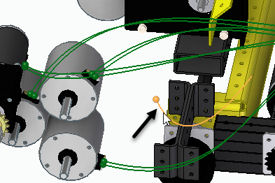Note wires are re-routed  
      through the bundle path.
    - 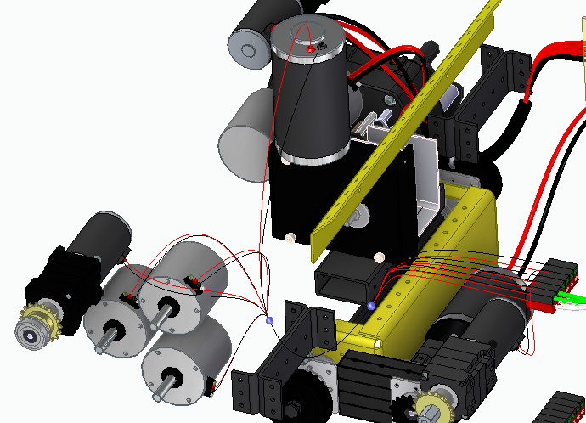Rename the Bundle to **Left Motors Bundle** and click Finish.

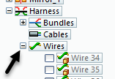**Video #4**

* Expand the Wires entry under Harness at the bottom of the PathFinder.
  + Note any wires that have a gray arrow in front of them.
    - 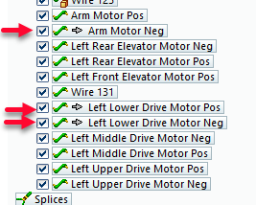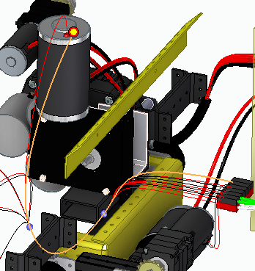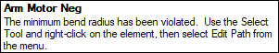This indicates that the wire has violated the minimum  
      bend radius for that wire definition.
    - Selecting the wire in the   
      PathFinder highlights that  
      wire, and the area of the violation,  
      in the graphics window.
* Hover over the wire and wait for QuickPick.
  + RMB click when the mouse icon appears.
  + 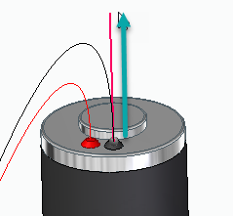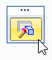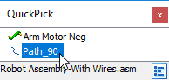Select the **Path** entry from the QuickPick  
    drop list.
  + Click the Edit Definition icon to edit the path.
  + Drag the end of the tangency handle upward to   
    increase the bend radius coming out of the motor.
    - Click Finish
    - 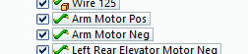Check the PathFinder to be sure the arrow  
      has been removed.
    - 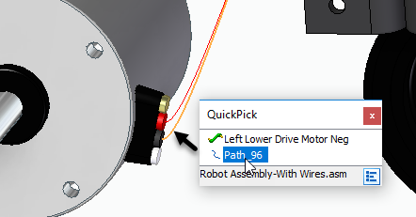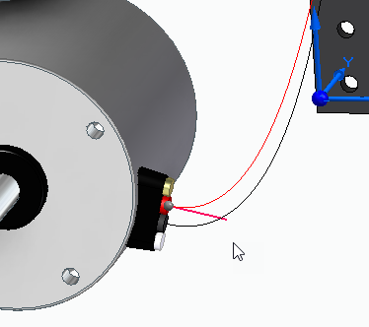Repeat these steps to increase the radius at the point where it attaches to the motor.
  + 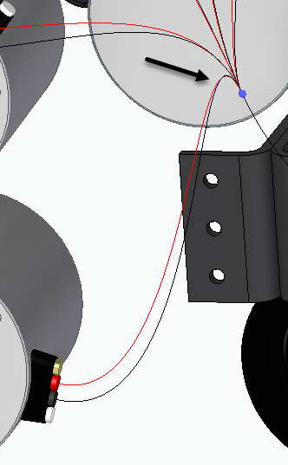Note we still have gray arrows in front of the   
    wires in PathFinder.  
      
    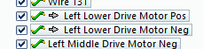
  + In this case, the radius entering the bundle   
    also violates the minimum radius value.
    - Note that there is no tangency  
      handle to adjust where the wires enter  
      the bundle.
    - We must add points along the paths that   
      we can adjust to change the radius  
      entring this bundle
  + Hover over the red wire with the select tool   
    and use QuickPick to the select the wire path.
    - 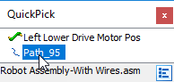Click the edit definition icon
    - Click on the Select Points Step in the command bar.
    - 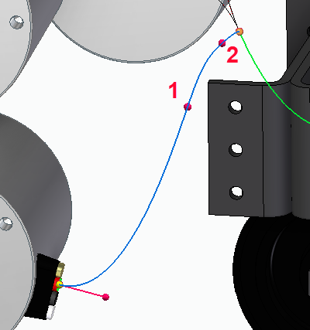As noted in the prompt bar at the bottom of the   
      screen, we can use Alt+Click to insert points   
      along the path.
      * Use this method to add 2 points as shown.
    - 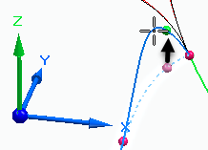Select the Z Axis of the triad to lock the direction   
      to drag point #2 upward.
    - 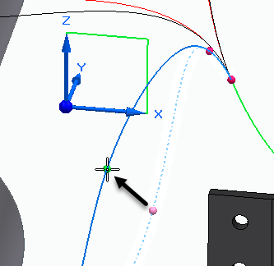Select the X,Z Plane of the triad to lock the plane   
      to drag point #1 outward to make a smooth arc.
      * Click the green checkmark to accept  
        the edits to the points and then  
        click Finish.
      * 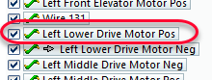Note the radius viloation has been  
        fixed for this wire.
  + 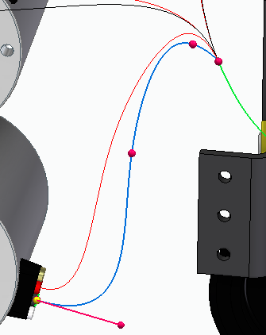Repeat the above steps to fix the black wire.
* 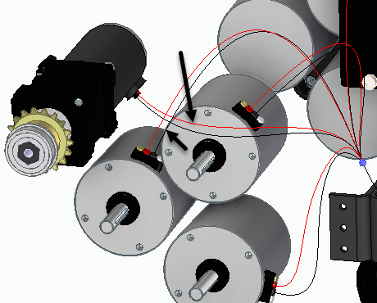If you look carefully, you can easily see that the Left Front Elevator   
  wires and the Middle Drive Motor wires run through the   
  Upper Drive Motor.
  + We can fix this by adding points along the   
    paths to adjust the wire route.
  + Remember that you must use QuickPick  
    to edit the paths for the wires.
  + 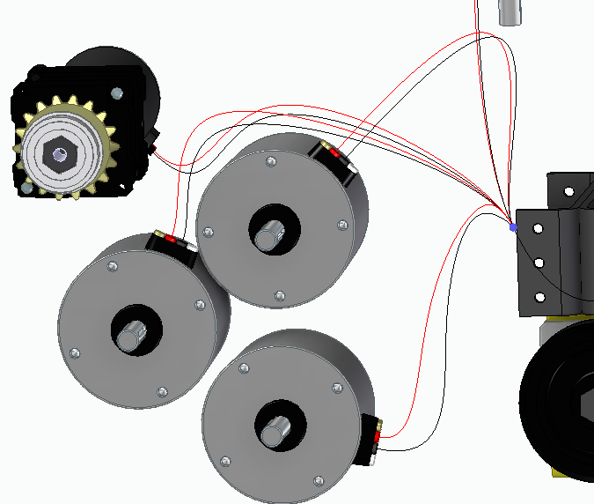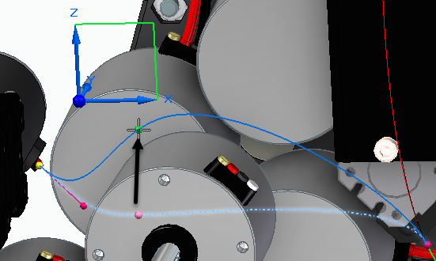Use the Select Points Step and   
    use Alt+click to add points to the  
     path and to adjust the points.
* 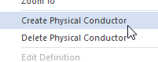To create the physical models of the wires simply RMB click on the   
  Harness entry at the bottom of the Pathfinder and click   
  “Create Physical Conductors”.
  + RMB click on Harness again and click Hide to turn off the   
    display of the wire paths.

**Video #5**

* On the Home tab, click the command to take an assembly Snapshot.
  + 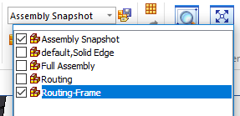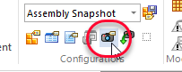From the configurations drop list select both the Assembly Snapshot and Routing –Frame configurations to display.
* 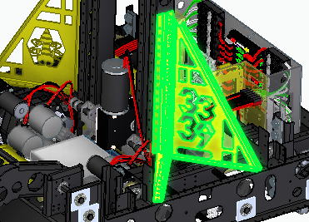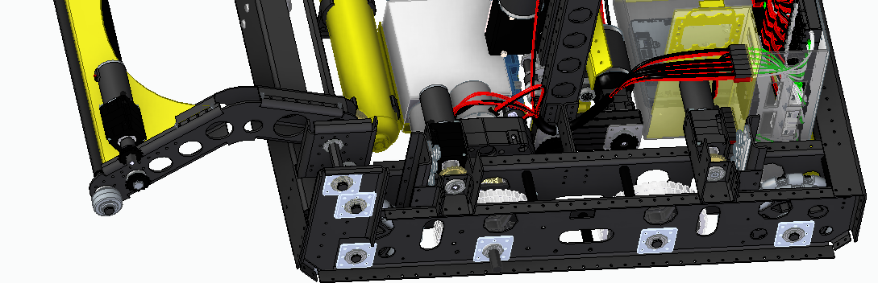Select the 2 vertical support brackets and RMB click and select Hide.
* Hover over the Left Rear Elevator assembly and use QuickPick to select the assembly from the list.
  + 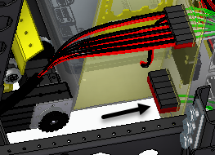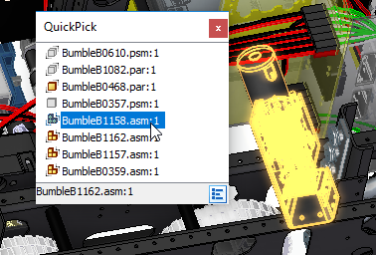RMB click and select Hide to expose the lower set of Connectors.
* 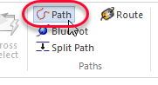Next we will use the Path command to route positive and negative wires   
  from the Ball Retrieval Motor to the outside bottom Connector.
  + Be sure that the Path connects the terminals of the same color.
  + 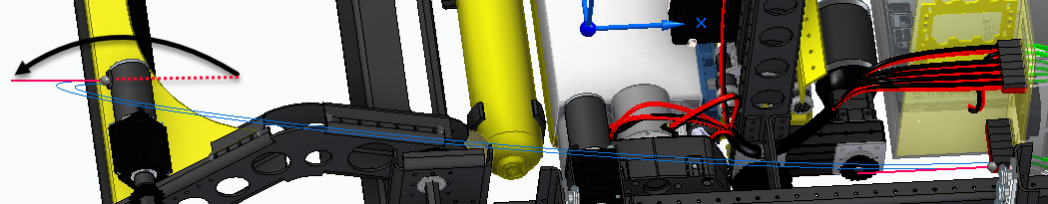Note you will have to click and drag the tangency handles on   
    the motor-end to switch the direction the wires exit the   
    motor terminals.
* 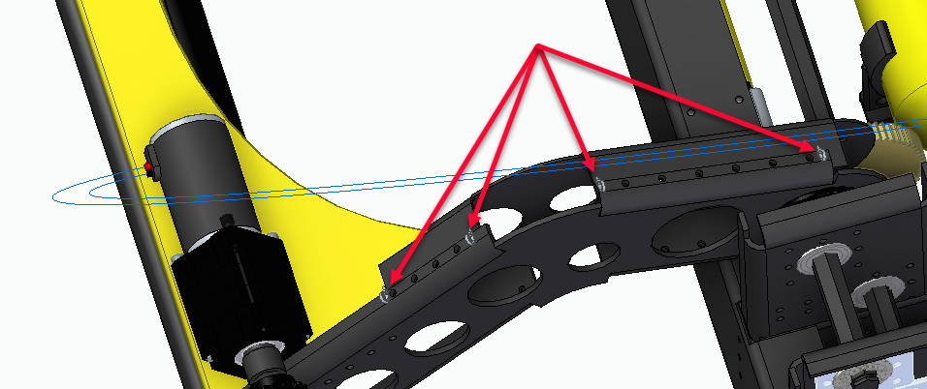The next step is to route the paths through the 4 small wire ties mounted to the Ball Retrieval Arm.
* 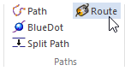Select the Route command from the Home tab and graphically select the red   
  terminal’s path.
  + Rotate the view like shown to make selecting the zip ties much easier.
  + Hover over the front face of the zip tie ensuring the previw of the path  
    shows it will go through the tie in the correct direction.
    - * 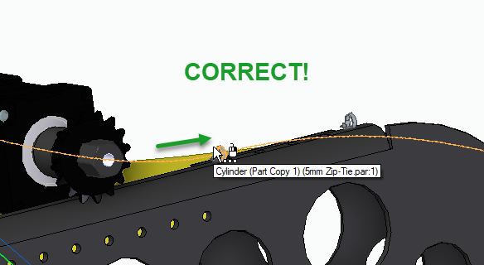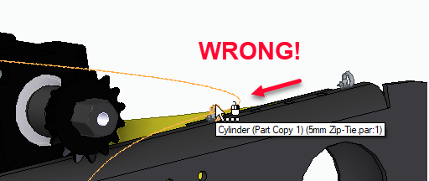Move on and off the wire tie to get it to flip direction.
  + 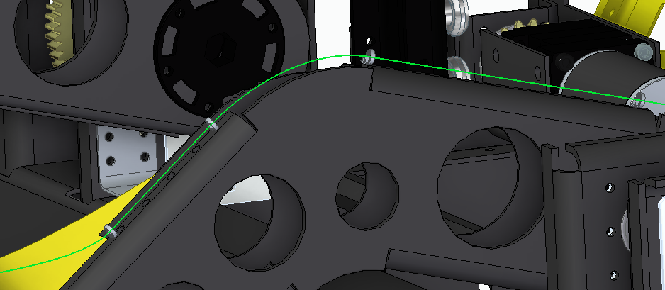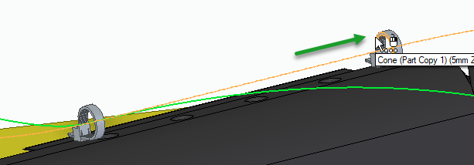Continue to route through the remaning 3 zip ties, ensuring the direction is correct before clicking on the face of the zip tie to accept the route.
  + Run the route command again and select the Black terminal’s path and route through the same 4 zip ties.
    - 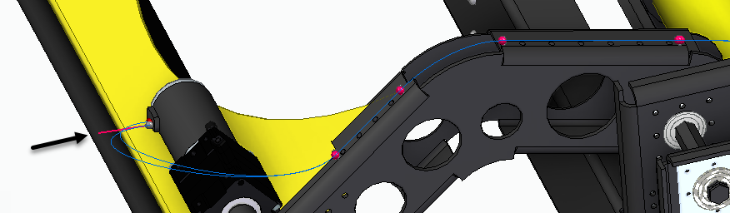You may wish to edit the paths, once routed, to adjust the tangency on the motor end of the paths as shown.
* 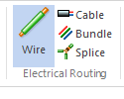Next we can ues the Wire command with the “Use Existing Path” option to assign:
  + **12-gage** **Stranded Copper Red** and name it **Ball Retrieval Motor Pos**
  + 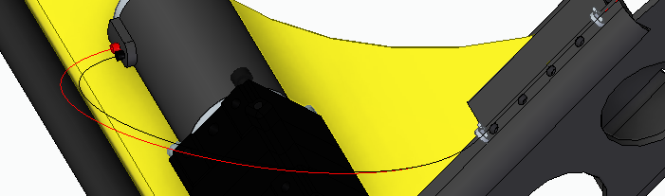**12-gage Stranded Copper Black** and name it **Ball Retrieval MotorNeg**

**Video #6**

* We want to take advantage of the Bundle we created earlier to route the 2 new wires we will create through the same Bundle path.
  + So as to not lose the work of routing the paths through the wire ties, we will create a split in each path just beyond the 4th zip tie.
  + 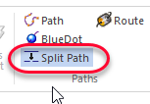Run the Split Path command and select the wire path as shown.
    - NOTE!: Pay close attention to the name of the path   
      being split (Path_113 in this image)
    - 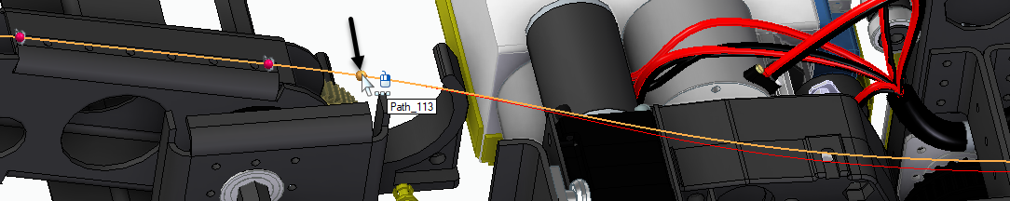Click to split the path.
  + Run the Split Path command again and click on the other wire path (Path_112 in this image) to split.
    - 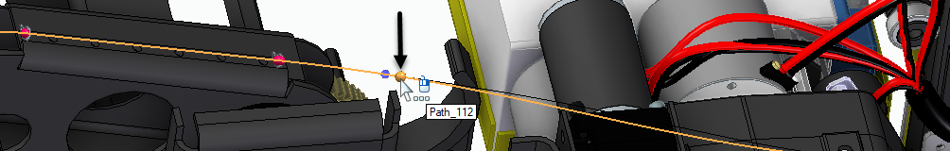You may need to use QuickPick to select it.
  + Now we are ready to route the wires through the bundle.
    - In the PathFinder, expand Bundles in the Harness collector and highlight the Left Motor Bundle and click the Edit Defintion icon that appears.
    - 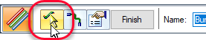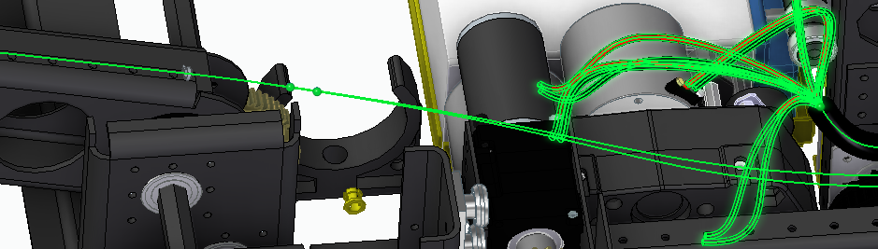Click the Conductor step and add the 2 new wires by selecting the wires on the **bundle side** of the path splits that we created earlier and accept with the green checkmark, and click Finish.
  + 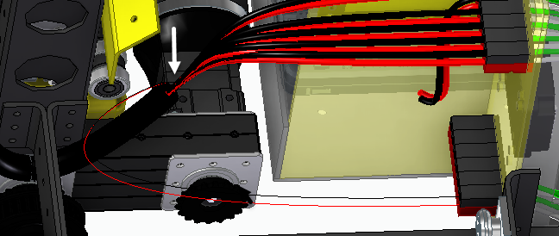Note the wires exiting the Bundle bend sharply downward to the lower connector, which we will need to fix so as not to violate the minimum bend radius.
  + 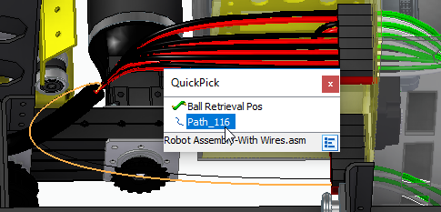  
      
      
      
    - Hover over the red wire and then   
      use QuickPick to select the wire Path.
    - 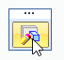Click the Edit Definition icon.
    - 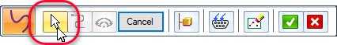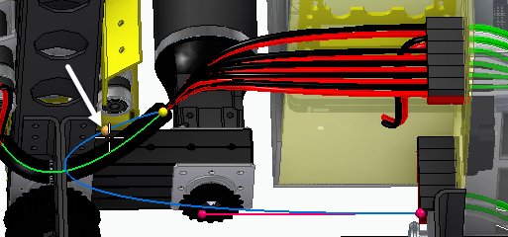Click on the Select Points Step and press the Alt key as you click on the path to   
      add edit points.
    - 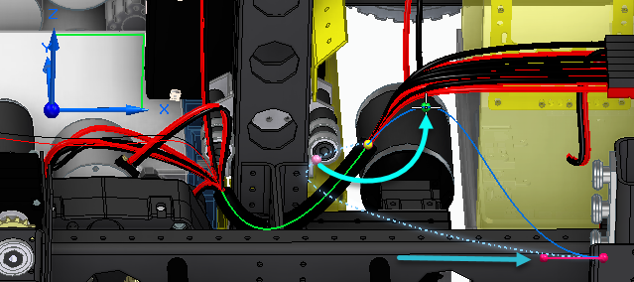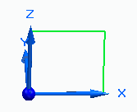Lock to the X,Z Plane of the triad and adjust the tangency   
      point and new edit point as shown to create a smooth   
      transition out of the bundle and into the connector.
    - 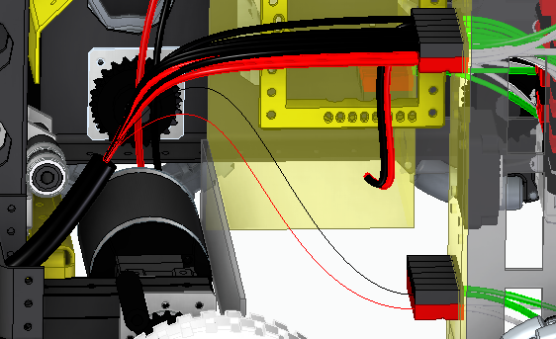Repeat these same steps to adjust the path for the black wire.
* 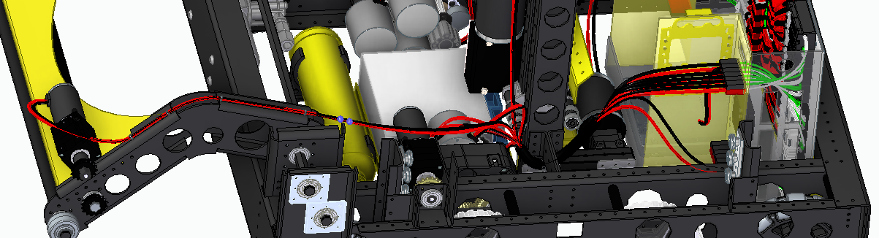Select the 2 new wires and from the RMB click menu, select Create Physical Conductor.
*  On the Home tab, click the command to take an assembly Snapshot.
  + 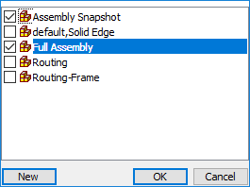From the configurations drop list select both the Assembly Snapshot and   
    Full Assembly configurations to display.

**Video #7**

* 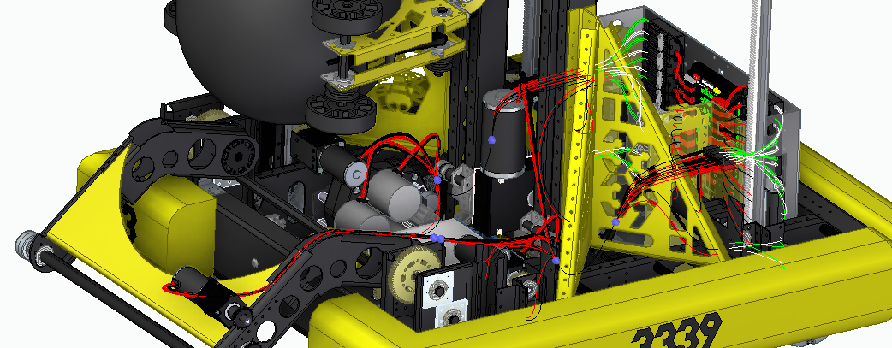RMB click on the Harness entry in Pathfinder and select “show” to display the wires.
* 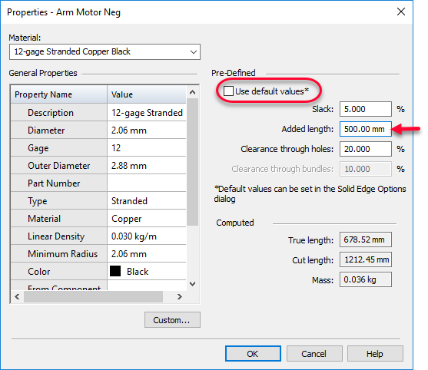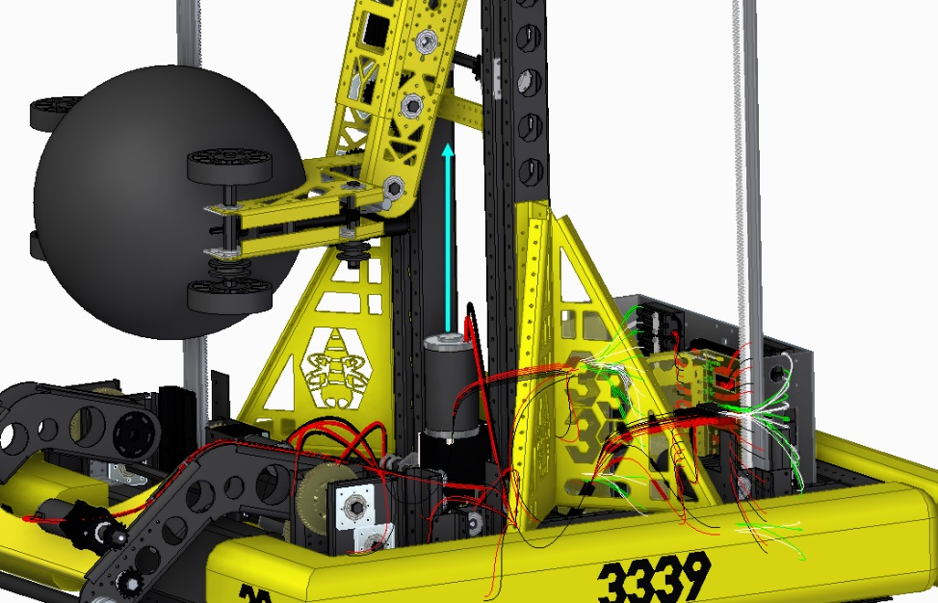Note the Arm Motor travels upward with the Vertical Lift mechanism, therefore the wires must be much longer than shown.  
    
    
    
    
    
    
    
    
    
    
    
    
    
    
    
  + We can manually add the wire length   
    needed in the wire properties for both   
    the positive and negative wires.
    - Select one the wires and select   
      Properties from the RMB click   
      menu.
    - Uncheck “Use Default Values”   
      and change the added length   
      to 500.00 mm.
    - Repeat for the other wire.
* RMB click on the top level assembly in the PathFinder and click “Hide” to hide all parts and subassemblies.
  + RMB click on Harness in PathFinder and select “Show”
  + 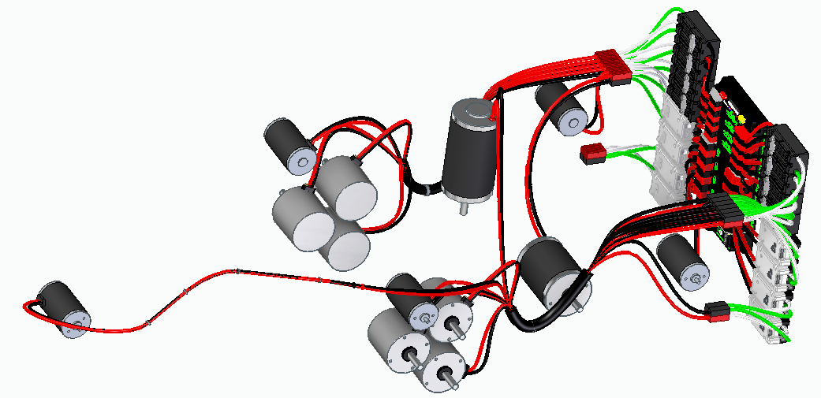RMB Click on Harness and and select “Show Connected Components” to see just the wires and what they are connect to.
  + RMB click on Harness in PathFinder  
    and select “Hide”
* 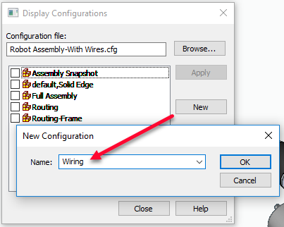On the Home tab click on the configurations command and   
  create a new configuration named Wiring.
  + 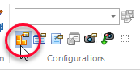Close the Configurations dialog
* Save the assembly
* On the Tools tab, select the Harness Report command.
  + 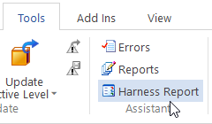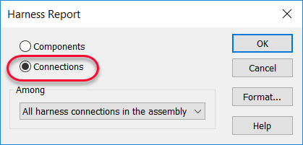Set the report to “Connections” and click OK.
  + The report shows wire names (ID) and the wire cut lengths.
    - 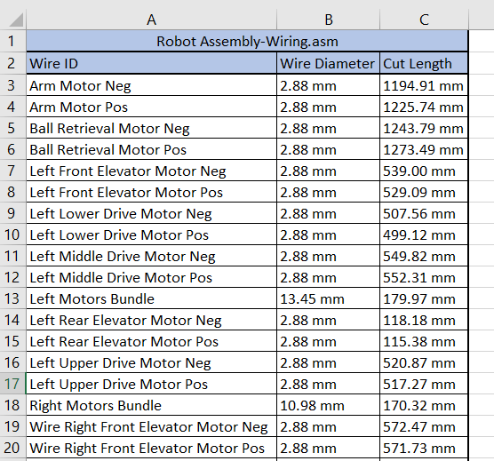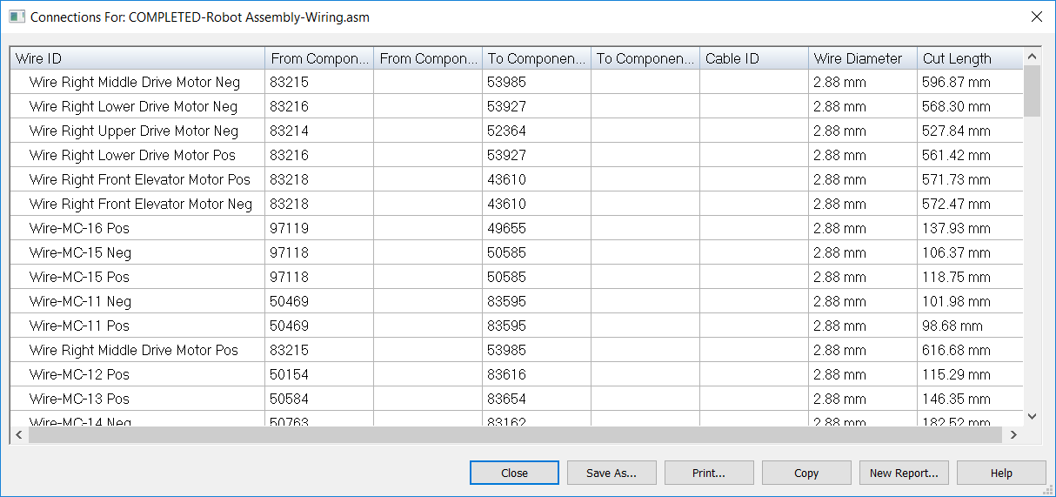The information can be copied to the clipboard and pasted into an Excel Spreadsheet  
      where the columns can be sorted and organized.

**Video #8**

* 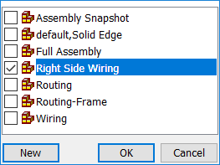We can also create callouts to tag the wires with their Wire Names  
  and cut lengths.
* Open the configurations dialog box again and activate the Right Side Wiring   
  configuration by selecting it and click OK to dismiss the dialog.
* 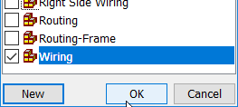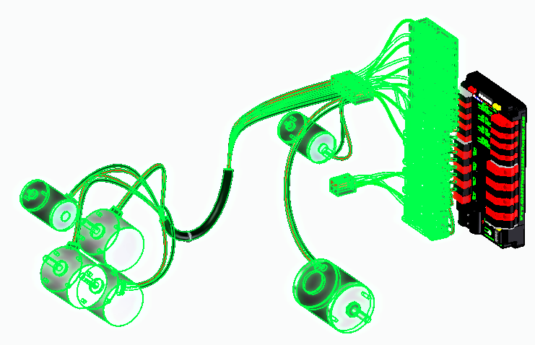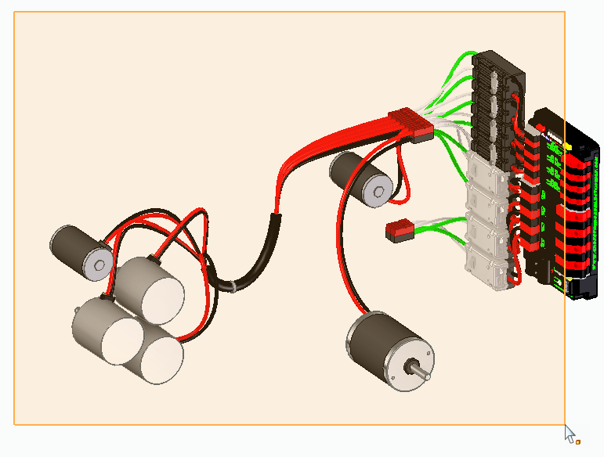Rotate the view so that you can create a drag a selection box around all the parts except the Power Distribution Panel as shown.
* With these parts selected, from the configuration drop list, select the Wiring   
  configuration.
  + 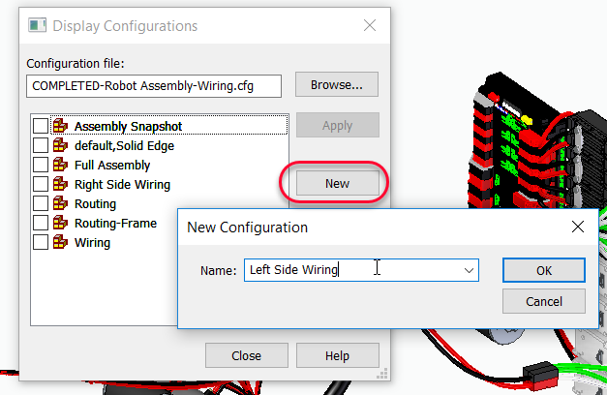Click OK to dismiss the dialog.
* RMB click in the graphics area and select   
  Hide to hide the selected parts.
* Open the configurations dialog again and   
  create a new configuration:
  + **Left Side Wiring**
* 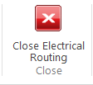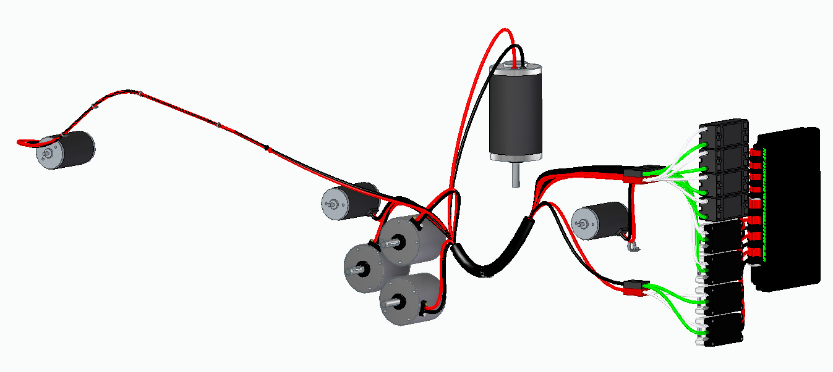Close the Electrical Routing environment   
  and save the Assembly.
* Rotate the view approximately as shown to create annotations for the left side wires.
* 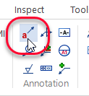From the PMI tab, select the Callout command.
  + 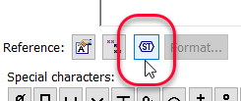Select Symbols from the Reference group.
* 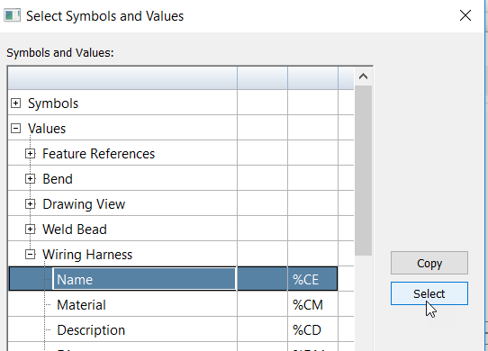In the Symbols and Values dialog, expand   
  Values and then Wiring Harness.
  + Click **Name** and pick select.
  + Click **Cut List** and pick select.
  + Click OK to dismiss.
* 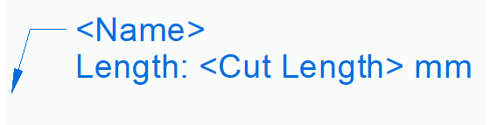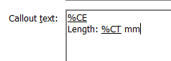Add the following text as shown on a   
  second line.
* 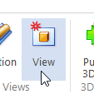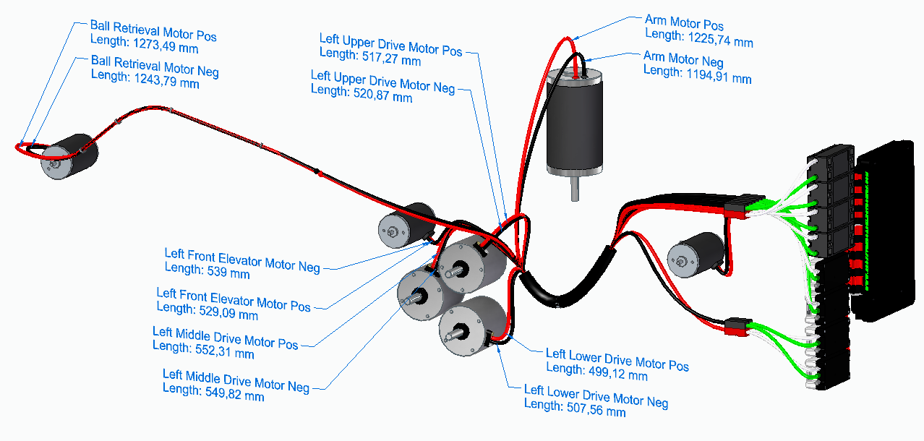Click on the wires and create callouts for each of the motor wires.
* 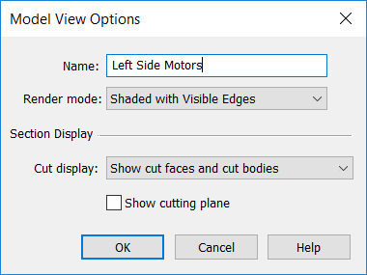Click View on the PMI tab to create a Model View.
  + Name the model view **Left Side Motors**.
* 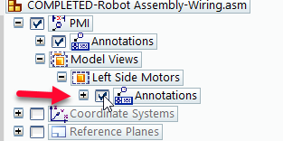In the PathFinder, expand the Annotations node under  
  the Model view we just created.
* 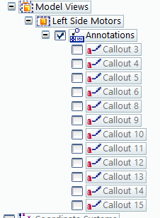Hide all the callouts by unchecking the callouts.
* On the Home tab, change the configuration to Right Side Wires.
* 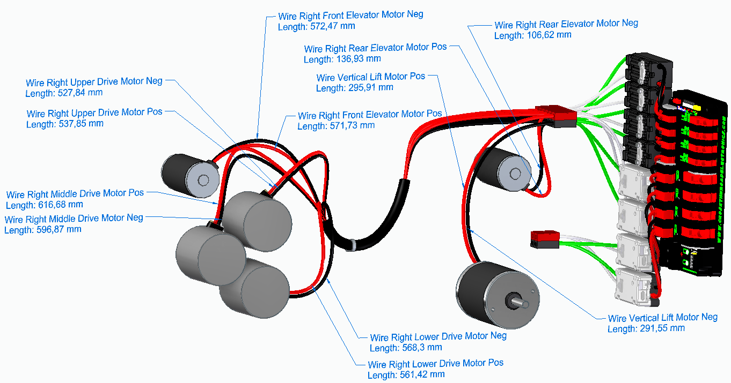Rotate the view and add the right-side motor callouts something like shown.
* Click View on the PMI tab to create another Model View.
  + 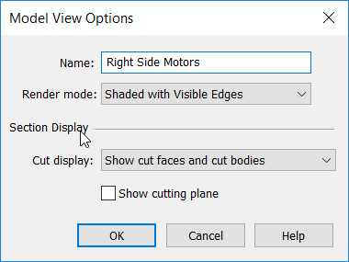Name the model view **Right Side Motors**.
* 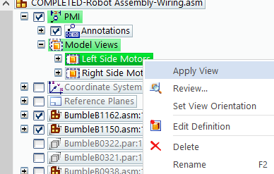By RMB clicking on each model view and clicking “Apply View”, you can toggle between them.
* Uncheck the Annotations to hide all of the callouts.
* Change the configuration to display Full Assembly and Wiring to see the completed Assembly.
* 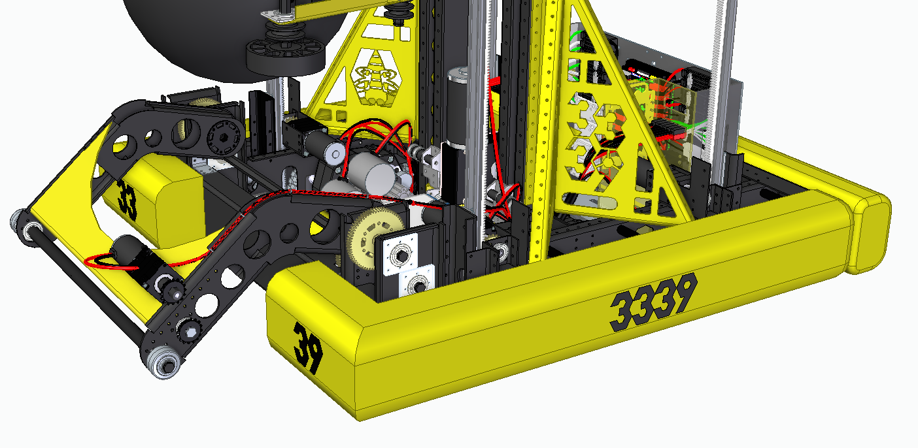Save the Assembly

© 2019 Siemens. A list of relevant Siemens trademarks can be found here. Other trademarks belong to their respective owners.